Mobile Usage Research

MARKETING RESEARCH ABOUT

# Introduction

Given the usage of mobile devices is growing rapidly, it is important to understand in depth, the different factors that affect users. Our project goal is to do a market research of mobile phone users and ask questions pertaining to their choice of network operator, mobile data usage, applications usage, emotions and feeling experienced while using their devices. Overall, we are looking to understand mobile phone user’s habits and preferences. The study was limited to UTD students.

Descriptive Statistics (more can be found in Annex)

**Gender**

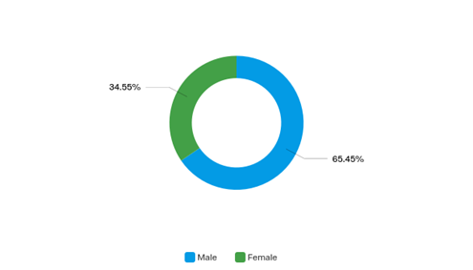

|  |  |  |
| --- | --- | --- |
| Answer | % | Count |
| Male | 65.45% | 36 |
| Female | 34.55% | 19 |

**Age**

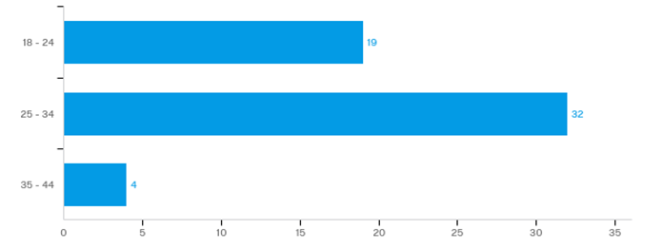

**Income level**

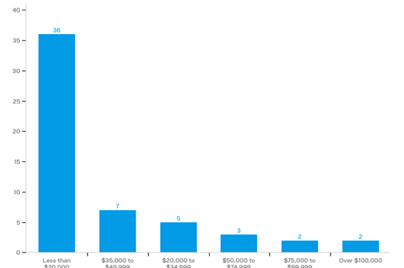

**Service provider**

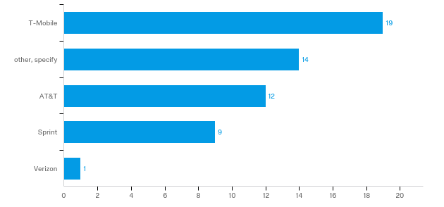

Of “other, specify”, we have 11 observations with Cricket.

**Monthly expenses**

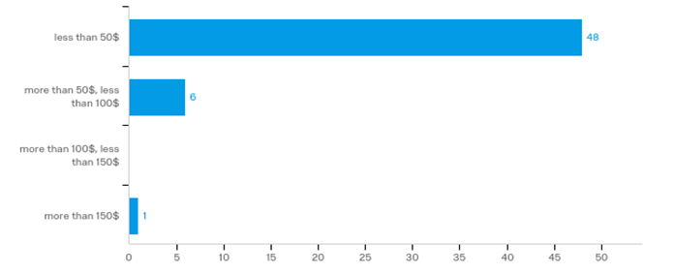

During our research, we came up with 5 hypotheses that we decided to test to determine if there was any conclusion we could reach from the data we collected. The first hypothesis is to determine whether there is any difference between mean happiness level of users using different network operators versus all other users. We looked at subscriber from AT&T, Sprint and Cricket.

Since majority of our users were students or employed individuals aged between 18 to 34, we asked them about how productive they feel while using their phones. Our second hypothesis is to determine whether there is any difference in mean level of feeling productive between age groups 18-24 and 25-34.

It also made sense to ask users how often they exceeded their data plans as allowed by their mobile operators. Our third hypothesis is to determine whether there is any relationship between age group and likelihood of exceeding data limits.

Our fourth hypothesis is to determine whether income level is related to likelihood of monthly bill going higher than expected.

The fifth hypothesis, we look whether gender may affect exceeding data usage.

# Survey Design and Results

Some of the sample questions from our survey are:

1. What is your income level?
2. Who is your network service provider?
3. How much do you pay on monthly basis?
4. How useful is group chat feature to you?
5. Within the last year, how many time did you exceed the maximum amount of data allowed on your plan?

Link to our survey: <https://utdallas.qualtrics.com/jfe/form/SV_6StjK0Gg9deSXAx>

From the one-month period we ran the survey, we obtained a total of 88 responses, 55 of which were from UTD students. Looking at figures 1.1 through 1.6, the results from the survey determined that most the respondents were 24 to 35-year-old Asians who are employed full time and have a 4-year degree.

# Data Analysis

The 5 hypotheses that we have selected from our survey are analyzed below followed by explanations of our findings.

**Hypothesis 1 (service provider Q11 and feeling happiness while using your phone Q29_1 )**

Null Hypothesis: There is no difference in mean happiness of AT&T and other users while using their phone

Alternate Hypothesis: There is a difference in mean happiness of AT&T and other users while using their phone

Welch Two Sample t-test

data: p$Q29_1[p$Q11 == 0] and p$Q29_1[p$Q11 != 0]

t = -0.7, df = 20, p-value = 0.5

alternative hypothesis: true difference in means is not equal to 0

95 percent confidence interval:

-0.733 0.380

sample estimates:

mean of x mean of y

3.92 4.09

Since the P value is greater than 0.05 we cannot reject the null hypothesis that there is no difference in mean happiness of users of AT&T and others.

Sprint vs Other – Happiness level

Null Hypothesis: there is no difference in mean level of feeling happiness of Sprint subscriber and others users

Alternate Hypothesis: there is a difference in mean level of feeling happiness of Sprint subscriber and others users

Welch Two Sample t-test

data: p$Q29_1[p$Q11 == 1] and p$Q29_1[p$Q11 != 1]

t = -0.7, df = 9, p-value = 0.5

alternative hypothesis: true difference in means is not equal to 0

95 percent confidence interval:

-1.413 0.751

sample estimates:

mean of x mean of y

3.78 4.11

Since the P value is greater than 0. we cannot reject the null hypothesis that there is no difference in mean happiness of users of Sprint and others .

Cricket vs Other – Happiness level

Null Hypothesis: there is no difference in mean level of feeling happiness of Cricket subscriber and others users

Alternate Hypothesis: there is a difference in mean level of feeling happiness of Cricket subscriber and others users

Welch Two Sample t-test

data: p$Q29_1[p$Q11 == 4] and p$Q29_1[p$Q11 != 4]

t = 2, df = 30, p-value = 0.07

alternative hypothesis: true difference in means is not equal to 0

95 percent confidence interval:

-0.0361 0.8088

sample estimates:

mean of x mean of y

4.36 3.98

Since the P value is greater than 0.05 we cannot reject the null hypothesis that there is no difference in mean happiness of users of Cricket and others. However, at 90% level of confidence, we can reject the null hypothesis and conclude that there is a difference in mean level of feeling happiness of Cricket subscriber and others users

Anova for happiness

Null Hypothesis: There is no difference in mean happiness of users of different mobile services while using their phone

Alternate Hypothesis: There is a difference in mean happiness of users of different mobile services while using their phone

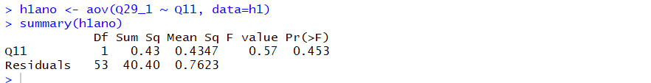

Since the P value is greater than 0.05 we cannot reject the null hypothesis that there is no difference in mean happiness of the different service providers.

**Hypothesis 2 (age group Q9 and feeling productive while using their phone Q29_2)**

18-24 and 25-34 age group – Productive level

Null Hypothesis: there is no difference in mean level of feeling productive while using your phone for age group 18-24 and 25-34

Alternate hypothesis: there is a difference in mean level of feeling productive while using your phone for age group 18-24 and 25-34

Welch Two Sample t-test

data: p$Q29_2[p$Q9 == 0] and p$Q29_2[p$Q9 == 1]

t = 0.3, df = 40, p-value = 0.8

alternative hypothesis: true difference in means is not equal to 0

95 percent confidence interval:

-0.466 0.627

sample estimates:

mean of x mean of y

3.74 3.66

Since p-value is greater than 0.05, we accept null hypothesis that there is no difference in mean level of feeling productive while using the phone for age group 18-24 and 25-34.

**Hypothesis 3 (age group Q9 and the likelihood of going over your data limits Q14)**

Null Hypothesis: There is no relationship between age group and likelihood of exceeding data limits under your current operator

Alternate hypothesis: There is a relationship between age group and likelihood of exceeding data limits under your current operator

> table(p$age, p$data)

O U

O 21 15

U 7 12

> chisq.test(p$age,p$data)

Pearson's Chi-squared test with Yates' continuity correction

data: p$age and p$data

X-squared = 2, df = 1, p-value = 0.2

Since p-value is greater than 0.05, we cannot reject the null hypothesis that there is no difference between age group and likelihood of exceeding data limits under your current operator

Anova

Null Hypothesis: there is no difference in mean rating for what they consider their phone, freedom or restriction, of users of different age groups.

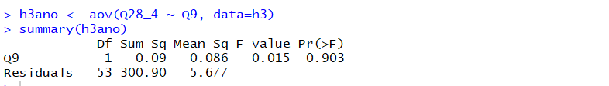

Since the P value is greater than 0.05 we cannot reject the null hypothesis that there is no difference in mean ratings.

**Hypothesis 4 (income Q6 and the likelihood of your bill being higher than expected Q15)**

Null Hypothesis: There is no relationship between income and likelihood of billing higher than expected.

Alternate hypothesis: There is a relationship between income and likelihood of billing higher than expected.

> table(p$income,p$bill)

O U

O 15 4

U 23 13

> chisq.test(p$income,p$bill)

Pearson's Chi-squared test with Yates' continuity correction

data: p$income and p$bill

X-squared = 0.7, df = 1, p-value = 0.4

chisq.test(p$age,p$data)

Pearson's Chi-squared test with Yates' continuity correction

data: p$age and p$data

X-squared = 2, df = 1, p-value = 0.2

Since the p-value is > 0.2, we cannot reject the null hypothesis that there is no relationship between income and the likelihood that the bill will be higher than expected.

**Hypothesis 5**

Null hypothesis : There is no association between gender and exceeding data limit

Alternate hypothesis : There is a association between gender and exceeding data limit

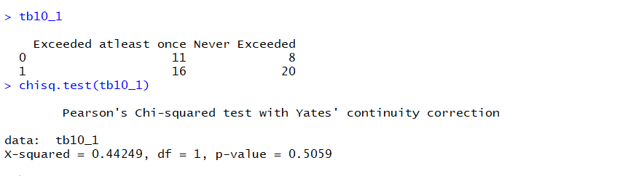

Since the P value is more than 0.05, we cannot reject the null hypothesis that there is no association between the variables.

## Final thoughts and recommendations

Our analysis and findings are based on the limited number of responses we could collect. Ideally, the more data we have, the more scope there is of unearthing interesting insights and making informed recommendations. We tried our best to obtain responses from the UTD student population and here we discuss some findings and possible recommendations an operator can use to attract subscribers.

* Hypothesis 1 revealed that there is no real difference between mean happiness among subscribers using major networks like AT&T, Sprint, Cricket etc. At 90% confidence level however, mean happiness level of Cricket subscribers is higher than the level of happiness of subscriber from other service providers.
* Any client doing market research should note that the there is a need to differentiate its brand and services in order to increase happiness level of subscribers
* Hypothesis 2 revealed that there is there is no difference in mean level of feeling productive while using your phone for different age groups. Our clients can conduct a further research as to how it can make the experience more productive for users across different age groups.
* Hypothesis 3 revealed that there is no relationship between age groups and likelihood of data being exceeded. Our clients can further take actions to understand what type of applications users across different age groups use. For example, students are more likely to use applications that are informative and interesting as compared professionals who are more likely to use professional applications. Network operators can partner with application developers to come up with applications targeting specific age groups to increase subscribers.
* Hypothesis 4 revealed that there is no relationship between different income groups and likelihood of higher than expected monthly bills. It seems that users with different income levels choose their plans wisely. This trait can further be exploited by adding innovative add-on packs to current data plans to make users consume more data.
* Hypothesis 5 revealed that there is no relationship between gender and likelihood of exceeding our data quota. Both male and female behave similarly.

ANNEX

**Gender**

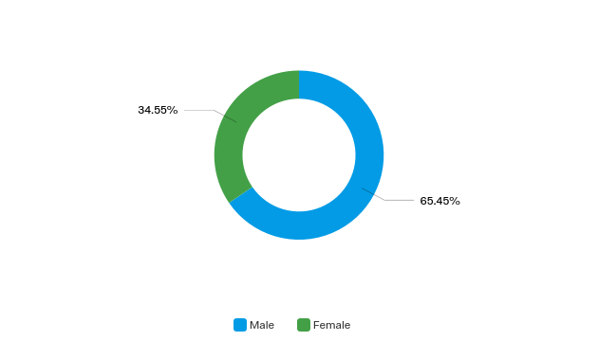

|  |  |  |
| --- | --- | --- |
|  | % | Count |
| Male | 65.45% | 36 |
| Female | 34.55% | 19 |

**Age**

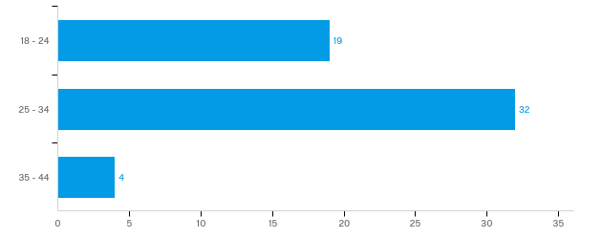**Ethnicity**

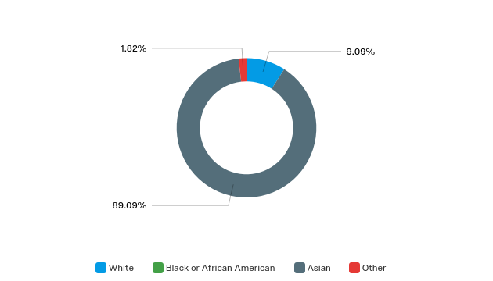

|  |  |  |
| --- | --- | --- |
|  | % | Count |
| White | 9.09% | 5 |
| Asian | 89.09% | 49 |
| Other | 1.82% | 1 |

**Employment status**

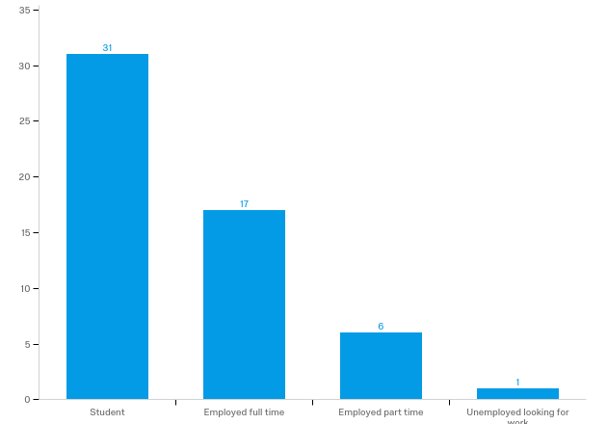

**Income level**

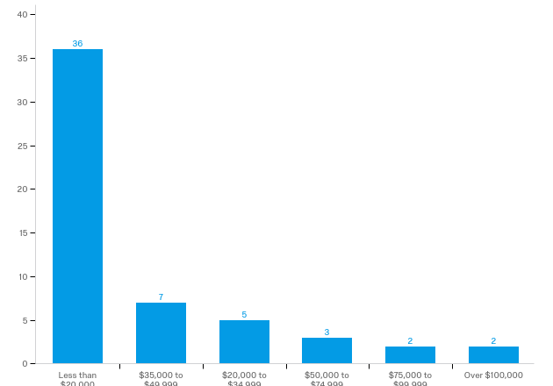

**Phone manufacturer**

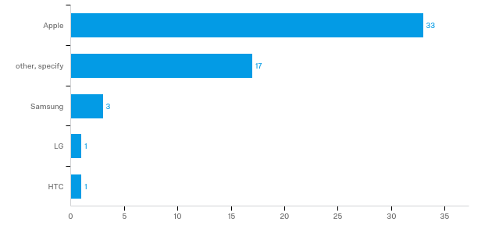

Of “other, specify”, we have 7 observations with Motorola and 5 with OnePlus.

**Service provider**



Of “other, specify”, we have 11 observations with Cricket.

**Type of plan**

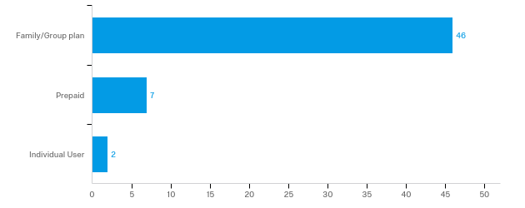

**Monthly expenses**

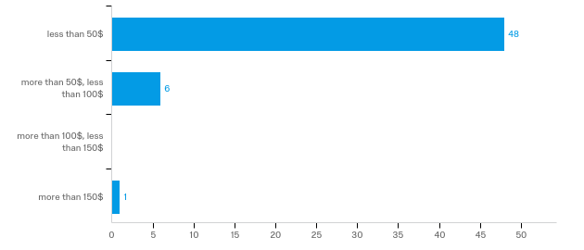

**Phone and semantic comparison**

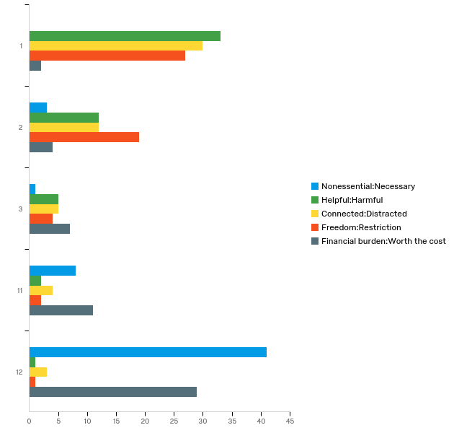

**Number of times maximum amount of data allowed on plan was exceeded (past year)**

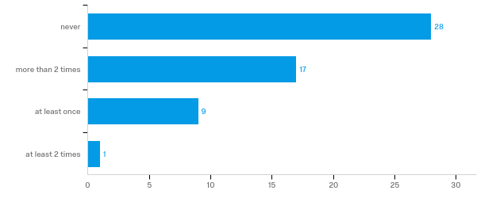

**Number of times monthly bill was higher than expected (past year)**

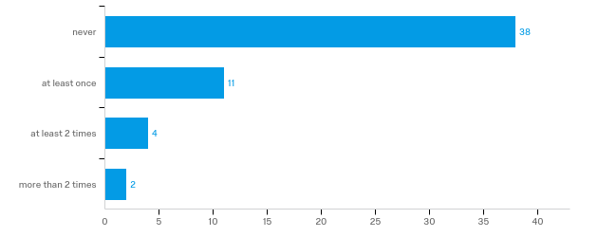

**Where phone is the most use**

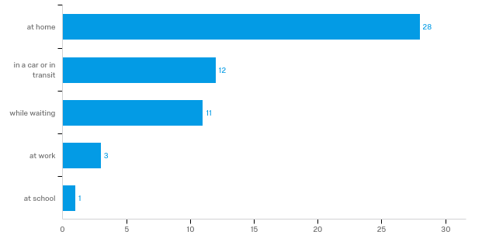

**Phone primary usage**

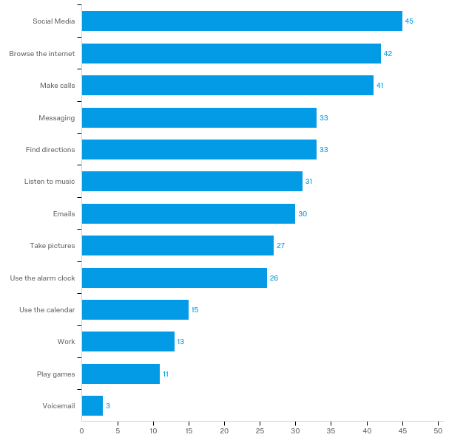

**Primary application for phone for social media**

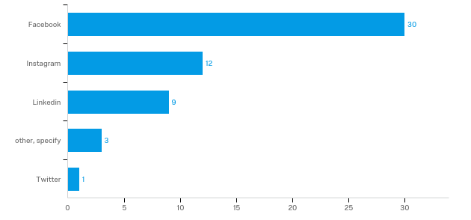

**Primary application for phone for messaging**

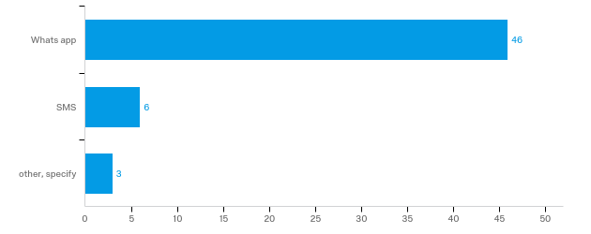

**First thing done on your phone every day**

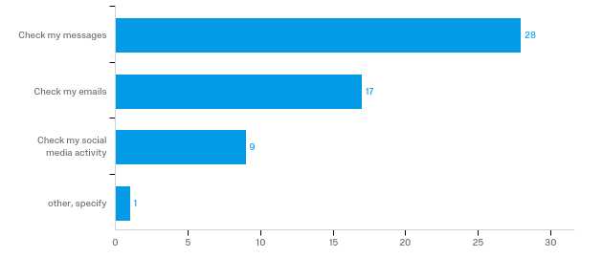

**Do you wake up in the middle of the night to check your phone?**

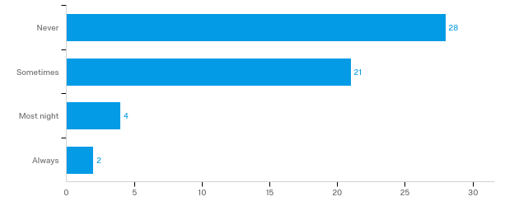

**Favorite apps**

|  |  |
| --- | --- |
| Whatsapp | 22.22% |
| Facebook | 15.15% |
| Instagram | 10.10% |
| Linkedin | 6.06% |
| Snapchat | 5.05% |
| Spotify | 3.03% |
| Email | 2.02% |
| Google maps | 2.02% |
| News | 2.02% |
| CamScanner | 2.02% |
| Internet Browser | 2.02% |

This question required a free text answer. Only 33 of the 55 survey responses had an answer for this question.

**Phone and emotions**

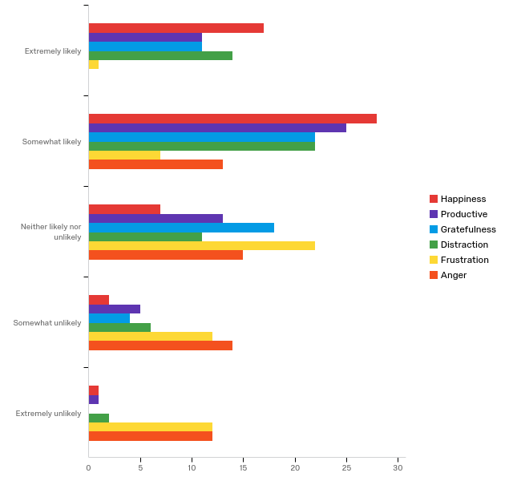

**Do you buy phone apps?**

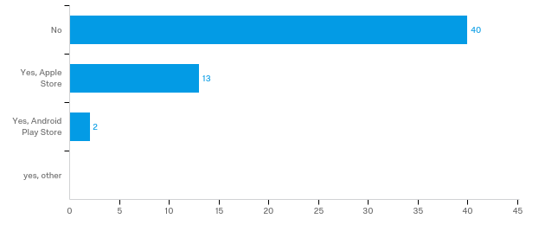

**Do you use your phone to make in store payment?**

